CRL SDR BOTTOM ROLLING SLIDING DOORS
Door Installation Manual

IMPORTANT: PLEASE READ BEFORE INSTALLATION
The following instructions will reduce your chances of experiencing problems during installation, and ensure smooth, trouble-free operation of the product

CONTENTS
Introduction page 2

Configurations page 3

Sliding Head Track Installation page 4

Bottom Sliding Track Installation page 5

Bottom Track Cladding Installation page 6

Fixed Panel Installation page 7/8

Sliding Door Leaf Installation page 9/10

Sliding door stops page 11

Introduction

Congratulations on your selection of the CRL SDR Bottom Rolling Sliding Door System. This system has been designed to work in a variety of different applications. Ease of installation and adjustment for height and alignment by incorporating all the features of the CRL Wedge-Lock Door Rail System make this the best choice you can make in Bottom Rolling Sliding Doors.

By following the instructions in this manual, we believe you will experience a trouble free installation of the system.
Should you have any question about this system or any other CRL products, please contact us at (800) 421-6144 or visit or website at www.crlaurence.com.

Configurations
Styles can be X, XX single track, XX double track, XO, XOX, OXO, OXXO
The width of each sliding panel must not exceed 48” (1220 mm).
Maximum weight per sliding panel not to exceed 234 lbs. (106 kg).
Below are typical configurations of SDR Bottom Rolling Sliding Door Systems.

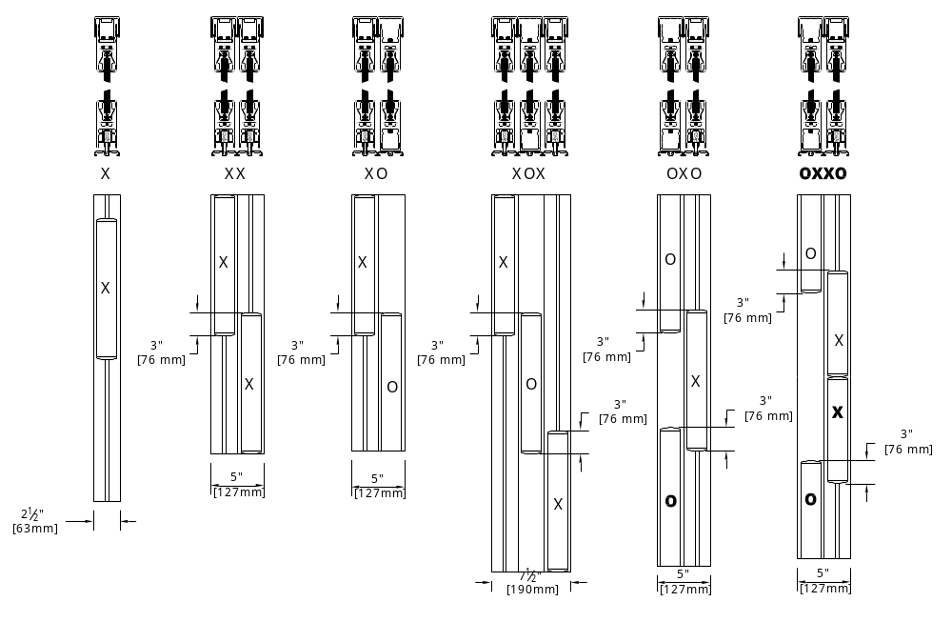

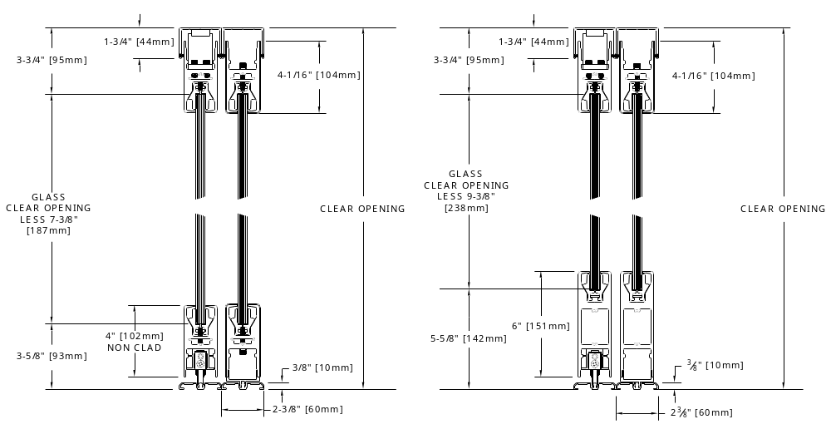

Top (Head) Track installation
SLIDING HEAD TRACK
The Sliding Head Track Assembly is packed complete with woolpile installed and where applicable, cladding.
On multiple track configurations, cladding is only applied to the outside of the outermost tracks. No cladding should be between the tracks.
The track/s must be positioned so that the screws have a strong and stable material to secure to.

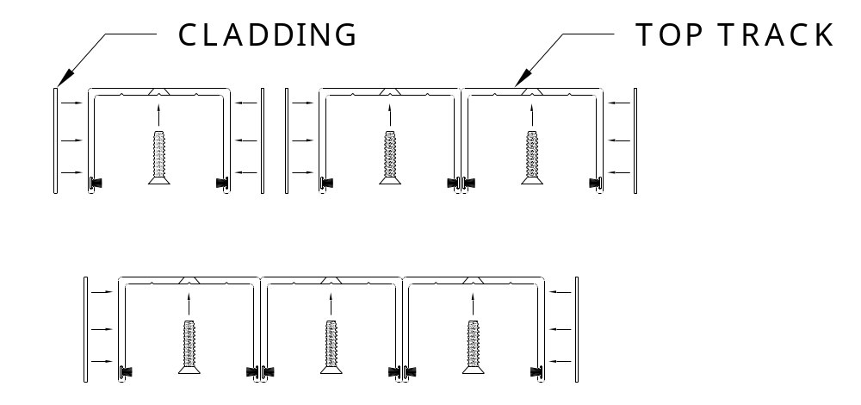

Drill and countersink the Head Track to take #10 screws (not provided). Holes should be no more than 12” apart. Screw lengths should be a minimum of 1” long and the head of the opening must be level and of sufficient strength to withstand the side loads of the sliding and fixed panels.

Bottom Sliding Track Installation
The bottom track is supplied with Stainless steel runners and lock holes for sliding panels. For multiple tracks, be sure that the tracks are in the correct arrangement.
The bottom track must be installed directly under the corresponding top track. Drill and countersink holes for #10 screws (not provided) into the track at no more than 12” apart. For multiple tracks, butt the tracks together for correct spacing.

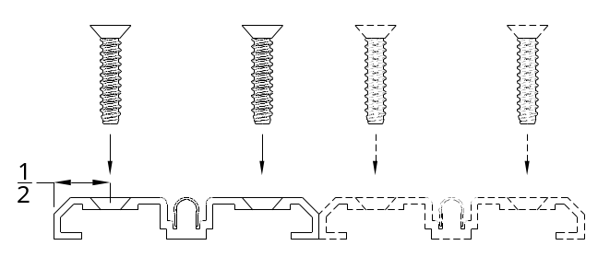

Cladding for the bottom track is supplied in various sizes to fit the configuration of sliding and fixed panels ordered. The sketch below identifies each part and its application. On the following page, there is a view of standard applications. Test fit all cladding before you remove the backing tape and press it on.
Note: sliding doors fit on the stainless steel capped tracks. Fixed doors fit on the non capped track.

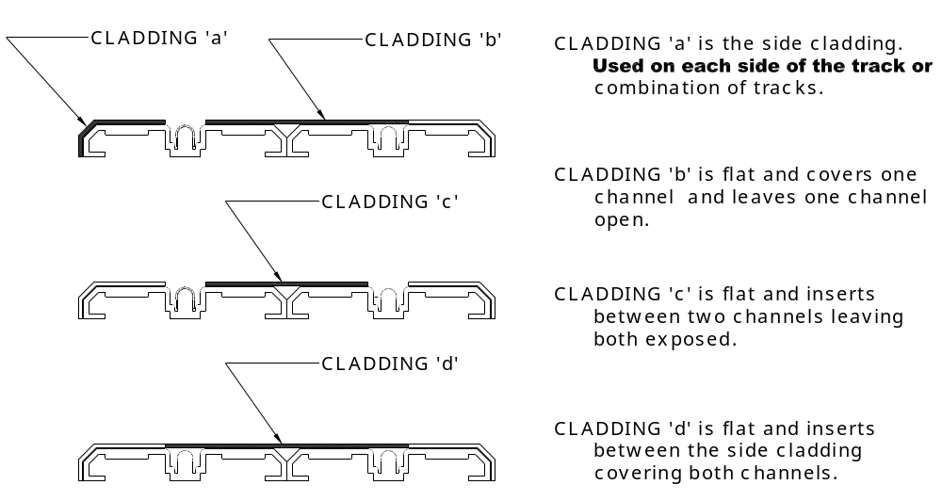

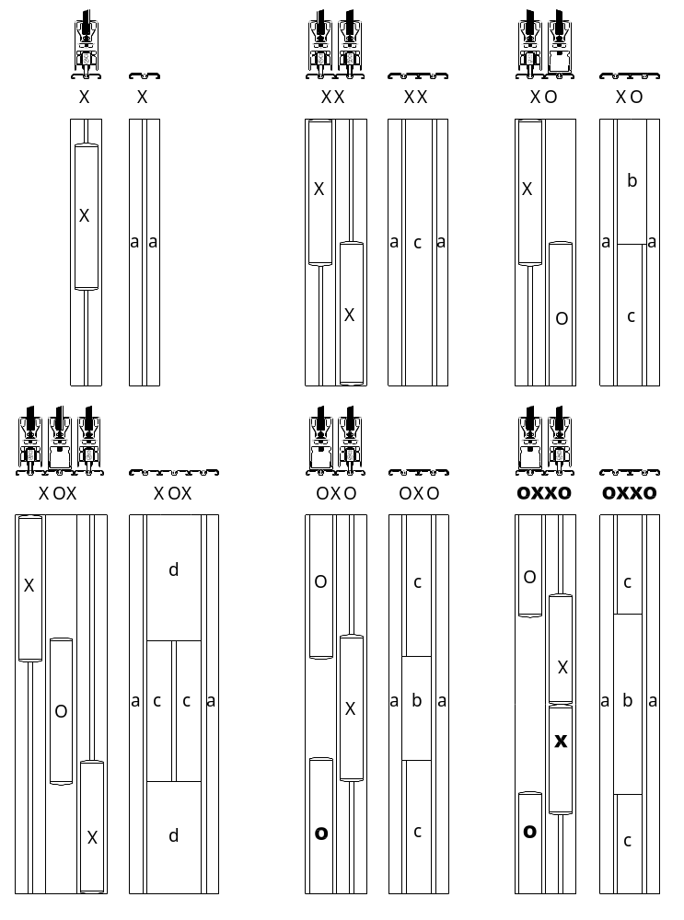
Fixed Door Installation
Assemble the Door Rails to the Glass as directed in the Rail Assembly Instructions included in the Door rail packaging.

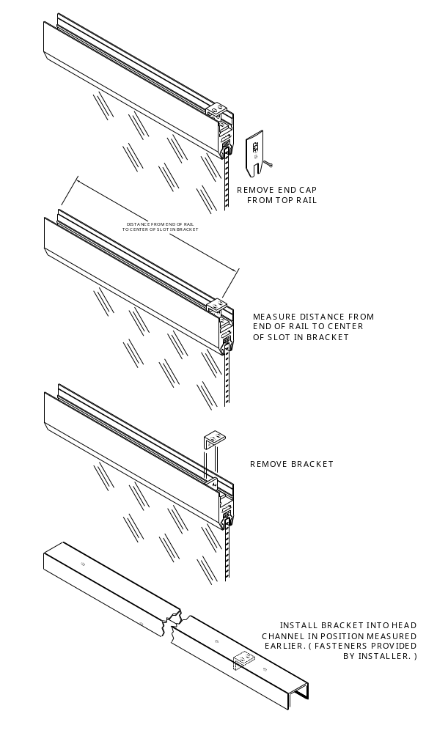

Fixed Door Installation - continued
Assemble the Door Rails to the Glass as directed in the Rail Assembly Instructions included in the Door rail packaging. Locate fixed panel saddle into track recess.

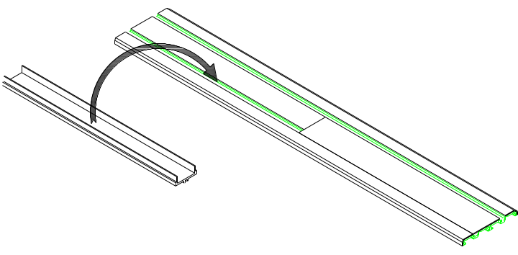

Raise the fully assembled fixed panel and insert the top rail into the head channel. Slide the panel over the saddle until the panel is in position. Secure the bracket in the head to the bracket on the top rail. Install end caps.

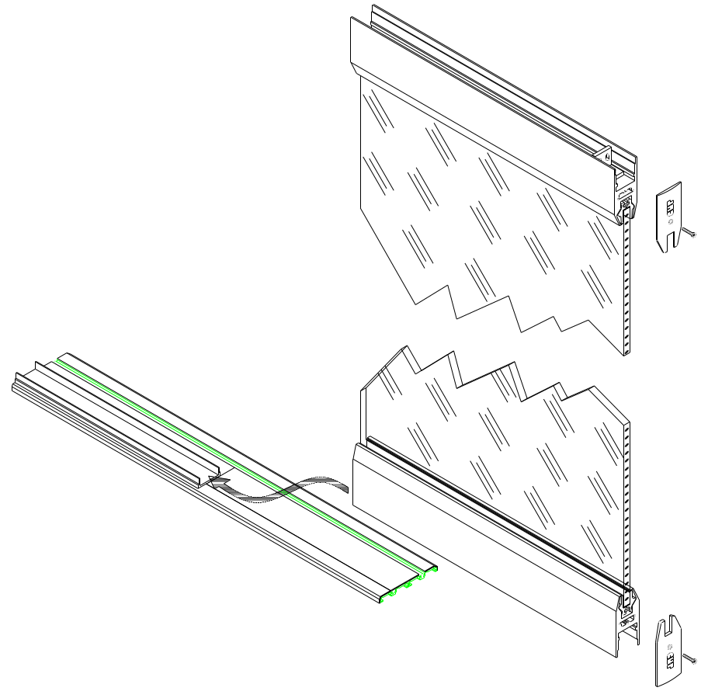

Sliding panel Installation
Assemble the Door Rails to the Glass as directed in the Rail Assembly Instructions included in the Door rail packaging. Raise the door up into the head track, then lower onto the stainless steel track.

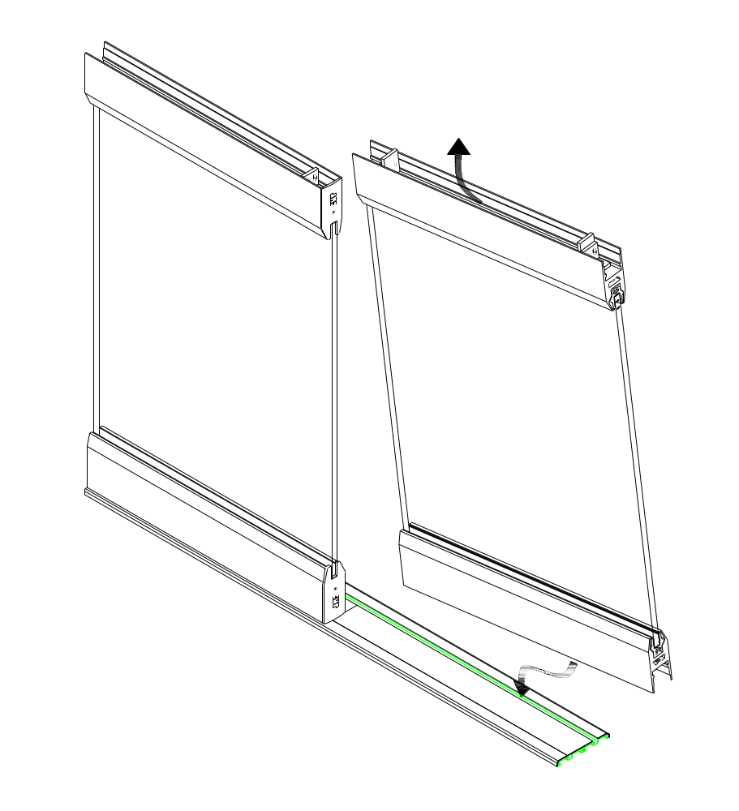

Sliding panel Installation – continued
Remove end caps from both top and bottom rails. Adjust the panel to the desired height by rotating the screw in the wheel assembly. This is accessed from the end of the rail. Be sure to raise the panel when making adjustments.
Once the door height is set, adjust the door stop/anti lift bracket at each end of the top rail to be within 1/16”-1/8” from the inside of the head track.

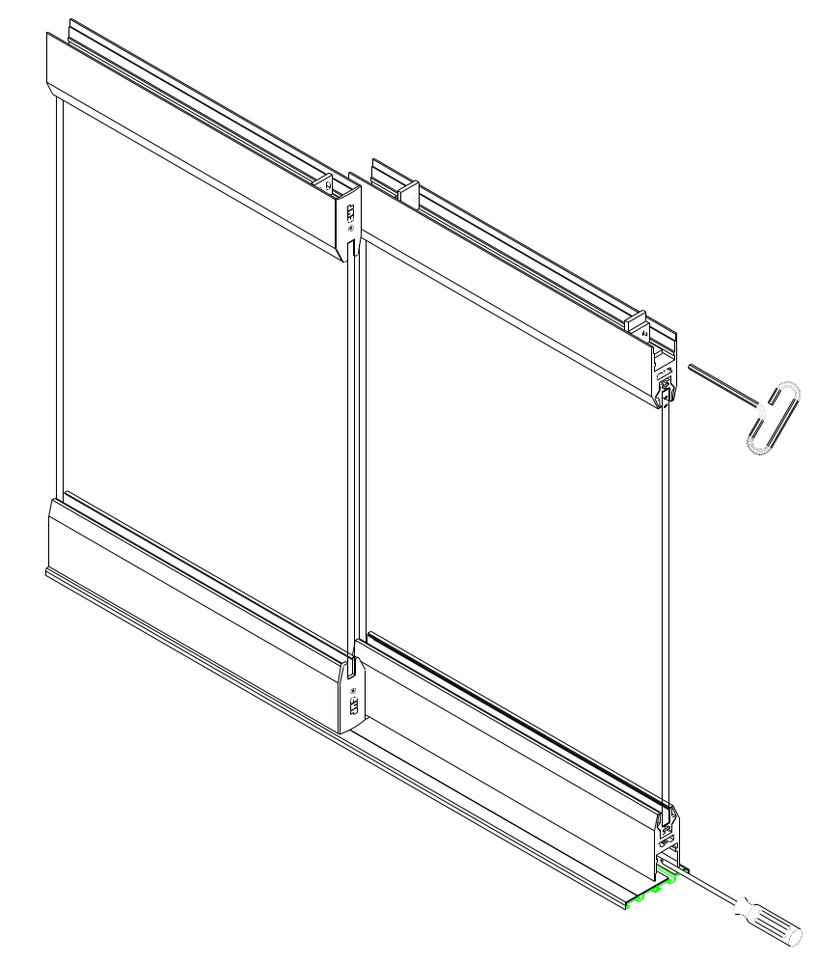

Sliding door stops
Move sliding door to stop position. Insert stop block against stop/anti-lift bracket and mark position. Move sliding door and install stop block into head with #10 screws (not provided).



